# Installation of RS-LiDAR packages for ROS

This guide will help you install everything you need in order to connect the RS-LiDAR-16 to a Raspberry Pi and to collect and visualize data. At the end of the guide you will find links to the different sites that were used to make this guide.

## Installing Ubuntu on your Raspberry Pi.

The first thing to do is installing Ubuntu on your Raspberry Pi. For this we are going to download a pre-made Ubuntu image that has ROS already installed on it. You can get the image from the link below.

Link: <https://downloads.ubiquityrobotics.com/pi.html>

For this guide I am using the 2020-02-10 release. The specifications are as follows.

|  |  |
| --- | --- |
| Operating system | Ubuntu |
| Version | 16.04 |
| Release | 10/02/2020 |
| ROS version | Kinetic |

In order the install Ubuntu on your SD card. We will first need to format the SD card. Removing every volume this there is nothing left. As can be seen in figure 1.

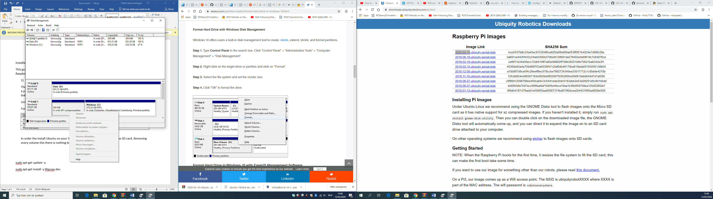

Figure 1: removing volume on external disk

After you have deleted everything you can make a new volume. Make it a FAT32 and give it a name you can remember.

After that is done we can install the Ubuntu image. For this we use BalenaEtcher. It is a free application that helps you install an image on an external drive.

Link: <https://www.balena.io/etcher/>

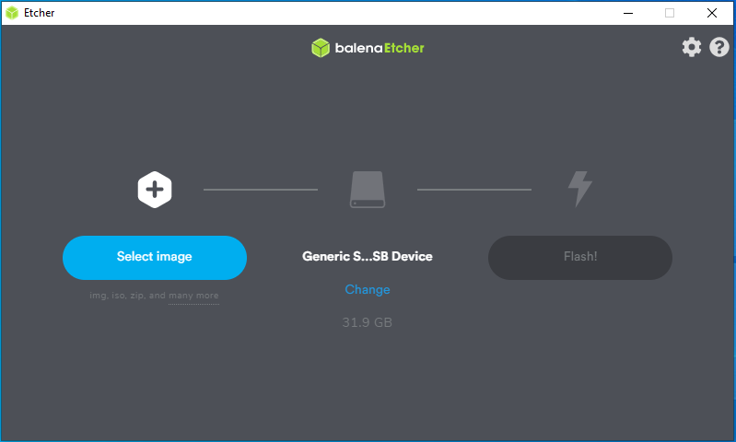

Figure 2: BalenaEtcher Interface

In BalenaEtcher select the image that you want to install and the SD card you want in to be installed. After that just click on flash and BalenaEtcher those the rest for you.

When BalenaEtcher is done you can close the application and remove the SD card and place it in the Raspberry Pi that you are using.

Now let’s boot up the Raspberry Pi. The password to login is:

ubuntu

Note: this operating system has ROS Kinetic already pre-installed on it. Because of this you do not have to use “roscore” when you want to execute a node of a launch file.

## Installing RS-LiDAR package on Raspberry Pi

The first and most important part is that you connect to the internet.

Now open a command prompt. In order to get the RS-LiDAR package to work on your device we first need to install libpcap-dev on your device. This can be done as follows. [1]

sudo apt-get update -y

sudo apt-get install -y libpcap-dev

After that we can begin installing and making the RS-LiDAR Packages.

Now we are going to clone the RPLiDAR package into the work space.

$ cd ~/catkin_ws/scr

Here we are going to clone the package from the git page.

$ git clone https://github.com/RoboSense-LiDAR/ros_rslidar.git

Now go back to the catkin_ws and make the package.

$ cd ..

$ catkin_make

The following command automates that sourcing process.

$ echo "source $HOME/catkin_ws/devel/setup.bash" >> ~/.bashrc

**Note:** this command ensures that the setup. Bash file is sourced when you open a new terminal.

Before we are going to launch the launch file of the RS-LiDAR-16 we first need to set a static IP-address for our ethernet port.

Let’s edit our network configuration file. [2]

$ sudo nano /etc/network/interfaces

There should be a line similar to this configuration. [2]

auto eth0

iface eth0 inet dhcp

Comment these lines and put the following lines below them. [2]

auto eth0

iface eth0 inet static

address 192.168.1.102

netmask 255.255.255.0

Save the changes and go out of the file. [2]

To apply the changes, use the following command. [2]

$ sudo systemctl restart networking.service

To check the changes

$ ifconfig

If the IP-address of the ethernet port is 192.168.1.102. You can try and ping the RS-LiDAR-16

$ ping 192.168.1.200

If you get a response back you now everything is setup right. Otherwise you will have to go back and check if you have setup your IP-address in the right way.

Now let’s try the launch file. In a new terminal put. [3]

$ roslaunch rslidar_pointcloud rs_lidar_16.launch

This should open a new window named RViz and you should be able to see some datapoint.

For more information go to the RS-LiDAR git page or via the links below.

## Reference List

|  |  |
| --- | --- |
| [1] | “How To Install "libpcap-dev" Package on Ubuntu,” ZoomAdmin, [Online]. Available: https://zoomadmin.com/HowToInstall/UbuntuPackage/libpcap-dev. [Accessed 13 March 2020]. |
| [2] | “Static IP Configuration on Ubuntu 16.04,” Snel, [Online]. Available: https://www.snel.com/support/static-ip-configuration-ubuntu-16-04/. [Accessed 13 March 2020]. |
| [3] | Tony-HIT, “readme.md,” Github - RoboSense-LiDAR, 11 September 2019. [Online]. Available: https://github.com/RoboSense-LiDAR/ros_rslidar/tree/master/doc. [Accessed 13 March 2020]. |

## Links

<https://github.com/RoboSense-LiDAR/ros_rslidar>

<https://github.com/RoboSense-LiDAR/ros_rslidar/tree/master/doc>

<https://askubuntu.com/questions/550937/change-from-qwerty-to-azerty-in-command-line>

<https://downloads.ubiquityrobotics.com/pi.html>

<https://www.balena.io/etcher/>

<https://zoomadmin.com/HowToInstall/UbuntuPackage/libpcap-dev>

<https://www.snel.com/support/static-ip-configuration-ubuntu-16-04/>